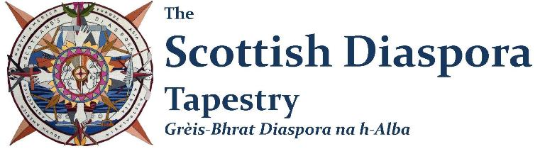

19th September - 1st October, 2016
St Andrew's Presbyterian Church, Scarborough, Toronto
Host: St. Andrew's Presbyterian Church

Canada’s multicultural diversity will be celebrated in Scarborough, Ontario, from September 19 to October 1, 2016, in a very special way. Ordinary Scottish folk including coalminers, trades-people, farmers and farm servants carried their strong work ethic, social institutions and values around the world. In their adopted communities they made new friends, learned together, and shared ideas, perspectives and dreams.
Almost twenty volunteers associated with one early Scottish community -- Scarborough, Ontario, Canada – completed three Diaspora Tapestry panels in celebration of the relationship between Scottish settlers and the Canadian forest almost 200 years ago. Symbolized in these panels are stories of hardship and survival, and others of prosperity, fellowship and faith – death by falling tree and stump remover; clearing the land for crops; sawmills for the construction of homes, barns and churches; cutting and selling masts for the shipping industry; and Alex Muir’s famous song “The Maple Leaf Forever”. Join us at St. Andrew’s for this fascinating exploration of their stories.
The first Presbyterian congregation in Toronto, St. Andrew’s celebrates their bi-centennial in 2018.
To learn more about our very interesting connection between the Scarborough exhibition of the Scottish Diaspora Tapestry and Scotland's Year of Innovation, please email bmccowan@netrover.com

